Saumil Bandyopadhyay (’13) was selected by the Virginia Department of Education along with five other high school students to represent Virginia and the United States at the International Space Olympics held October 18 - 30 at Korolev, a suburb of Moscow, Russia. Two hundred participants from west Europe, United States, Greece, Israel, China and Russia competed in the event. Saumil’s research project, in which he designed, fabricated and demonstrated a novel quantum wire detector capable of detecting stellar emissions and beta-particles emitted by cosmic events, was judged the overall best project. Saumil’s past research on wetting behavior of nanostructured surfaces, absorption studies of semiconductor nanowires, and infrared and ultraviolet photodetectors have won multiple awards at regional and state science fairs, the Google Science Fair and the Intel International Science and Engineering Fair. He and his co-workers have published their research in multiple international peer-reviewed journals.

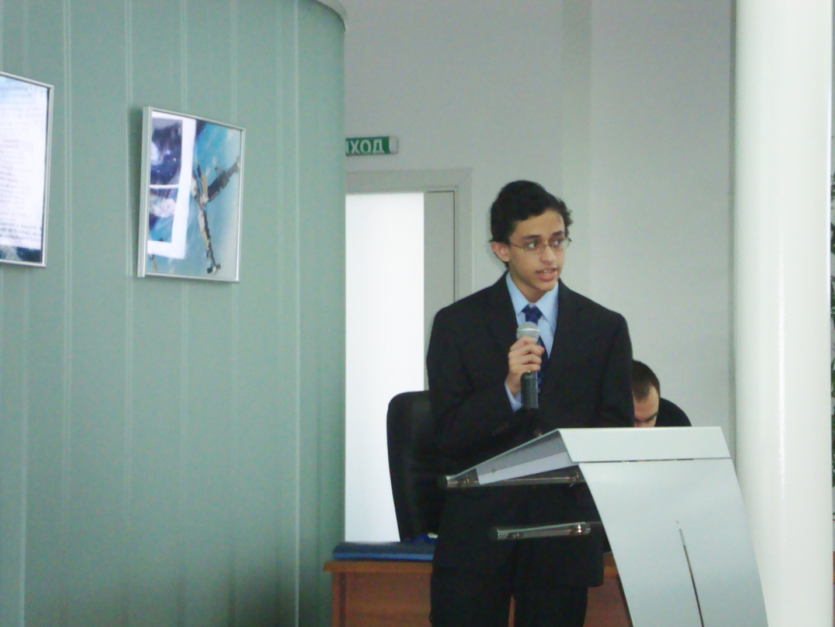

Saumil answering questions from the judges and the audience at Korolev. Photograph courtesy Mr. Ben Swecker.

